Conrad Blucher Surveying Collection Scanning Project

Project Overview and Map Exchange Procedure

Overview:

The Conrad Blucher Surveying Collection contains field books, land surveys, maps, and indices, as well as documents from three generations of the Blucher family. The documents are currently held and maintained by the Special collections and Archives department of the Texas A&M University – Corpus Christi Library. At this moment (08-08-14), more than 3000 maps have been scanned and saved to an external hard drive (TAMUCC Library: Expansion D) and to the HRI server. The scanned documents are currently being uploaded to the CBI server in addition to the HRI server. During the scanning process, map case drawers are transported from the TAMUCC Library to the NRC to be scanned. After the documents from both map case drawers are scanned and saved, the drawers are exchanged for more drawers that have not been scanned.

Map Exchange Procedure:

1. Schedule and approximate day to transport map drawers to and from the TAMUCC library

Points of contact:

Ms. Audrey Garza – Library Associate I

Phone: (361) 825-2300

Email: [audrey.garza@tamucc.edu](mailto:audrey.garza@tamucc.edu)

1. Schedule and reserve a vehicle for transport

Point of contact:

Mr. Chriss Shope – Field Operations Coordinator (BB SHED)

Phone: (361) 825-2887

Email: [chriss.shope@tamucc.edu](mailto:chriss.shope@tamucc.edu)

1. Transporting the drawers
   1. weather permitting (no rain or strong winds)
   2. drawers must be covered
   3. driver for van
2. Exchanging drawers
   1. Drawers are loaded and unloaded from the TAMUCC library loading dock (located behind the library across from the Bayside Parking Garage)
   2. Ask Audrey for a rolling cart which can be borrowed from the Systems/Media Office, room 108
   3. Special Collections and Archives is located on second floor, room 206. Audrey will open the back room (room 206) to the archives where the map cases are located.
   4. Replace scanned drawers and removed new drawers to be scanned.
3. Scan new maps
   1. all maps are kept in locked map case in NRC when not in the library
   2. To maintain the order of the map in one drawer after scanning, flip all the maps in the drawer before scanning

Conrad Blucher Surveying Collection Scanning Project

Equipment Procedures

1. Before turning on the scanner, the scanner must be inspected for dirt and debris. Open the lift of the scanner by pressing the raised buttons on each side of the scanner. Using a flashlight, inspect the glass for smudges or scratches.
   * If the glass in clean, close the lift and wipe down the exterior of the scanner with a clean cloth (orange). Be sure to wipe the back of the scanner were the map leaves the scanner and moves on to the holding surface. Clean the holding surface (white table) of any excess dust.
   * If the glass needs to be cleaned, use a clean cloth (white) and glass cleaner to gently wipe away the debris from the glass. **IMPORTANT**: Never spray the glass cleaner directly on the glass. Spray the glass cleaner on the cloth then gently wipe across the glass surface. Finally, use a clean dry cloth to remove excess glass cleaner and any remaining residue from the scanner.
   * Scanner lift is properly closed when two loud click are heard.
2. Turn on the scanner (ON/OFF switch is located on the bottom back of the scanner near the right side). The scanner display screen will display the message “Initializing”. Only after the scanner displays “**READY**”, can the scanning program be opened.
3. Open the *Scanworks 2.4.7.3* program. Located on the desktop.
4. In *Scanworks*, check the settings for filename/file location, size, and resolution/data type.
   * Filename: **BlucherScanning\Folder**(date)\**mapName**(found on corners of map)
   * Size: **Auto** radio button selected
   * Resolution/ Data type: **200dpi** , **RGB**

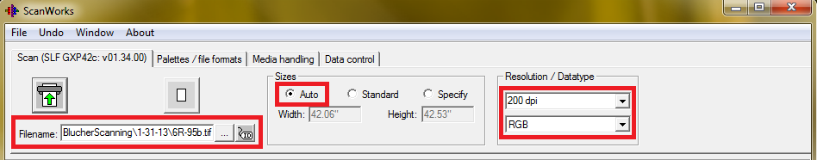

1. After scanning has been completed for the day, close *Scanworks* program and turn off the scanner.
2. Repeat step 1 before draping protective cloth over scanner and map holding surface.

Conrad Blucher Surveying Collection Scanning Project

Scanning Procedures

1. Scanner is on and in the “Ready” mode. *Scanworks* program running with all settings checked. Review Equipment Procedures for questions about scanner or scanning program.
2. Unlock map case and clean the top of the map case of any dust or debris. Use orange dusting cloth to wipe the surface of the map case.
3. Place the map to be scanned on the surface of the map case. Using a camel hair brush, sweep the map of clean of dust or loose materials. Be sure to thoroughly clean both sides of the map before scanning.
4. As you approach the scanner, place the map near the far right justified line. Once the sensors pick up the map, the scanner will load the map into position. Try to load the map as straight as possible, but this is not always possible. The map will typically load better if the longest side of the map is fed into the scanner. **IMPORTANT**: Maps that are particularly delicate (frayed edges, large tears, or with a large amount of tape) should be placed inside of the Mylar plastic sleeve before being inserted into the scanner. The Mylar plastic sleeve can only be fed into the scanner from the closed end.
5. Once the map has been loaded, return to the computer and confirm that the scan will be saved in the correct folder and with the correct file name. ( Drop down menu located in the upper left hand corner of the *Scanworks* program)
6. 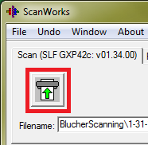Press the green arrow button in the top left corner of program to begin the scan. Watch the map carefully as it travels through the scanner and onto the holding surface. **IMPORTANT:** If for any reason the scanning process needs to be stopped in the middle of a scan, press the CANCEL button located on the scanner below the display screen. If the scanning process has been stopped, the up and down arrow buttons on the scanner can be used to manually remove the map from the scanner.
7. 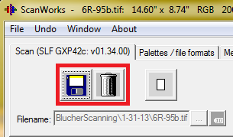When the entire document has been scanned. Open the folder in which the scan has been placed and view the image to actual size. Inspect the image for any blemishes. Depending on the severity of any blemishes located on the image, a second scan may be necessary to replace the current image. If the flaw is minor, save the image by selecting the floppy disk button. If the document needs to be rescanned, select the trash can button to delete the image.
8. If there is a secondary map or any form of notations on the reverse side of the map, repeat steps 4-7 for the reverse side of the map. This image should be saved as the name of the document plus the work back (Ex: 1-22back).
9. Return the map to the map case.
10. Before scanning another map the scanner glass must be inspected with a flashlight. If the glass is free of dust and residue, scan the next map following steps 1-10. However, do not scan more than five-ten maps without cleaning the glass following the procedures listed below.
    1. If the glass needs cleaning, begin by closing the *Scanworks* program (the program will freeze once the scanner is switched off for cleaning).
    2. **IMPORTANT**: Turn off the scanner before cleaning. If the sensors on the scanner are activated while cleaning the cloth may get caught in rollers.
    3. Proceed to clean the scanner glass as indicated in Equipment Procedures
11. To continue scanning, turn on the scanner and wait until Ready is displayed by the scanner to open *Scanworks* program and begin the process again.
12. After scanning is complete for the day, be sure to copy all scanned images onto the Library’s external hard dive. The folders are organized by map drawer; copy scanned images into appropriate folder.
13. Turn off, clean, and replace protective cover over scanner and holding surface.
14. Finally, lock the map case by threading the chains through at least three handles on the drawers and latch lock.